Basic Logic Program

1. **Display This Information using printf**

**a. Your Name b. Your Birth Date**

**c. Your Age d. Your Address**

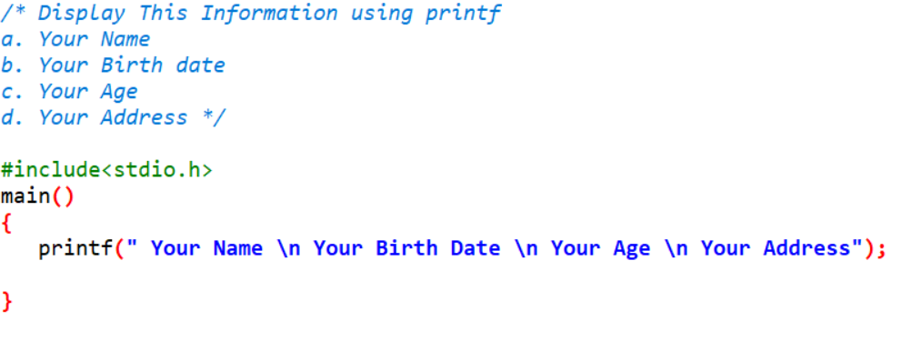

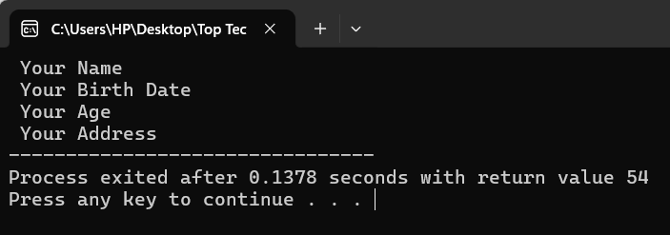**Output:**

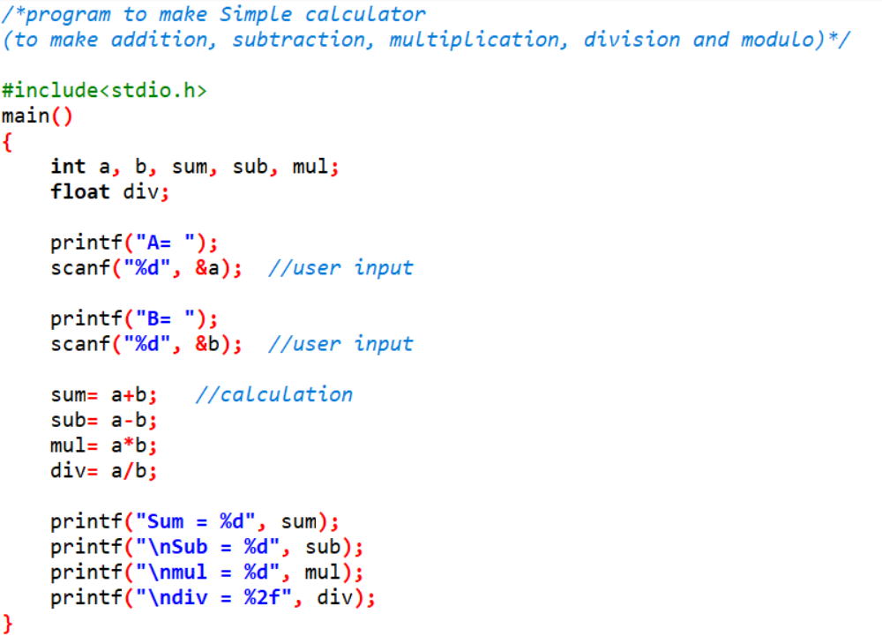**2. Write a program to make Simple calculator (to make addition, subtraction, multiplication, division and modulo)**

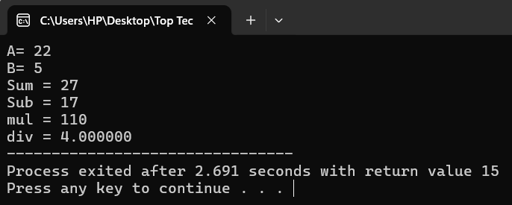**Output:**

**3. WAP to Find Area and Circumference of Circle**

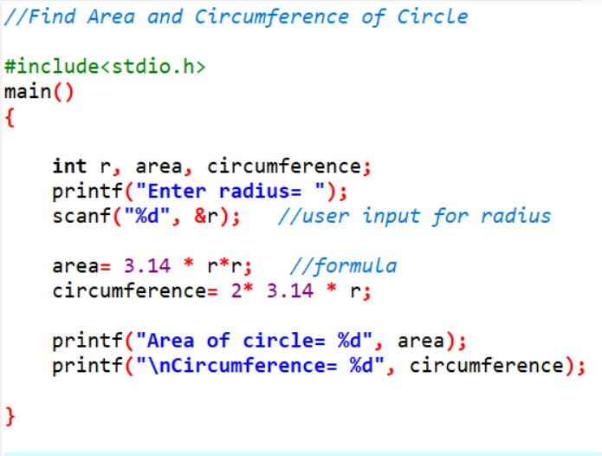

**Output:**

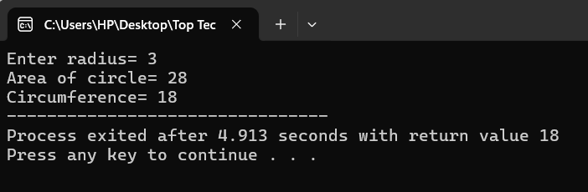

**4. Find Area of Square formula: a = a2**

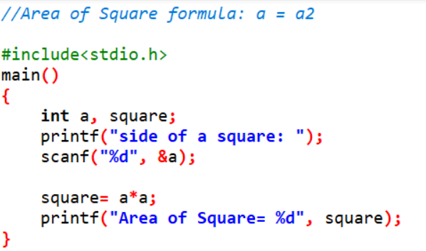

**Output:** 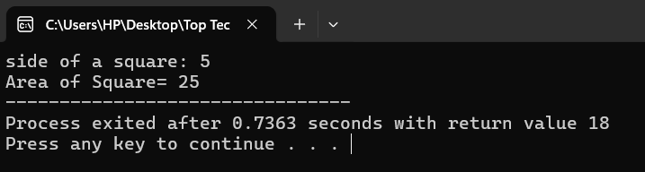

**5. Find Area of Cube formula: a = 6a2**

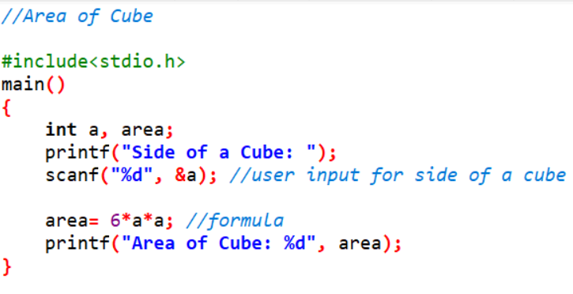

**Output:**

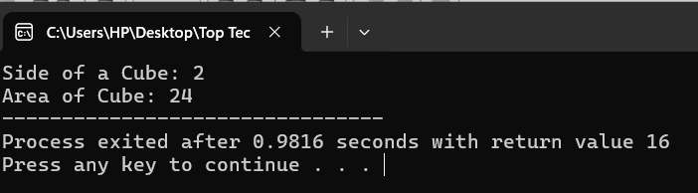

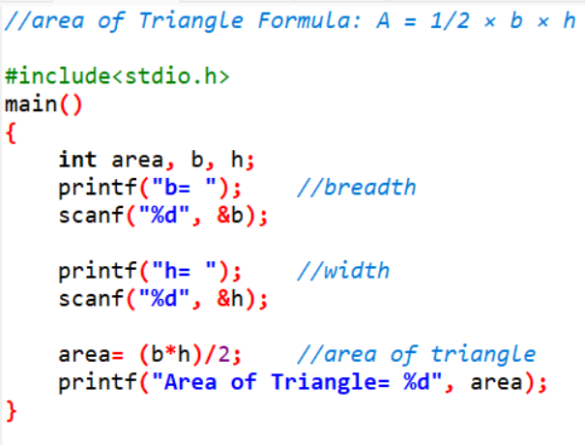**6. Find area of Triangle Formula: A = 1/2 × b × h.**

**Output:**

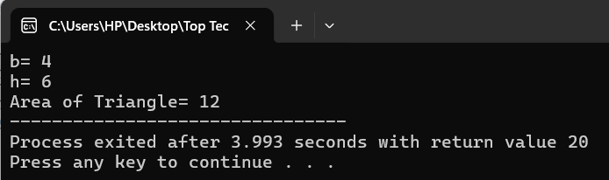

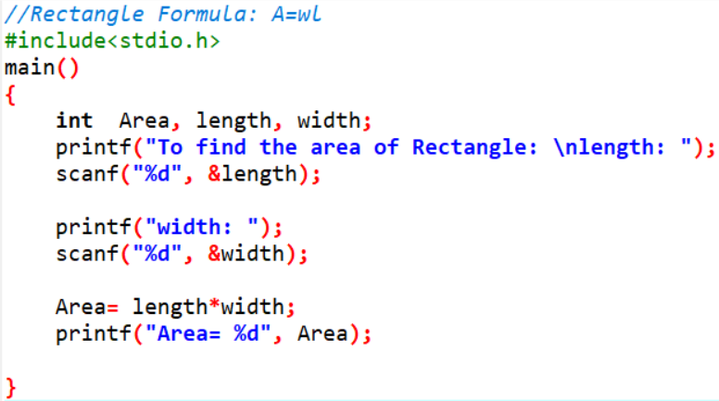**7. Find area of Rectangle Formula: A=wl.**

**Output:** 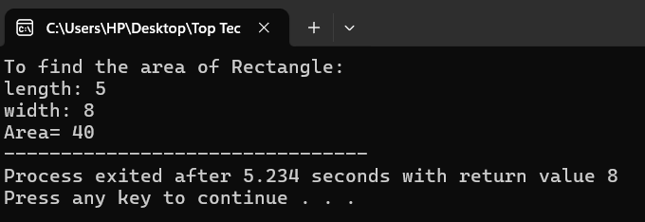

**8. Find circumference of Rectangle formula: C = 4*a.**

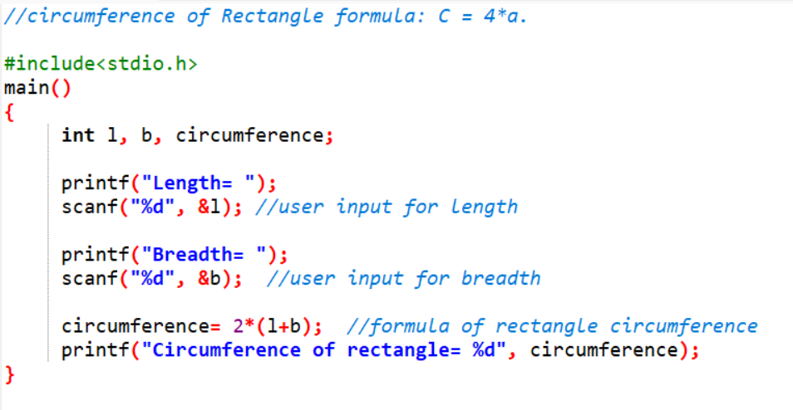**Output:**

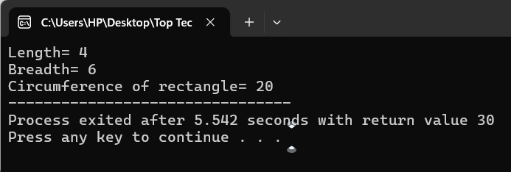

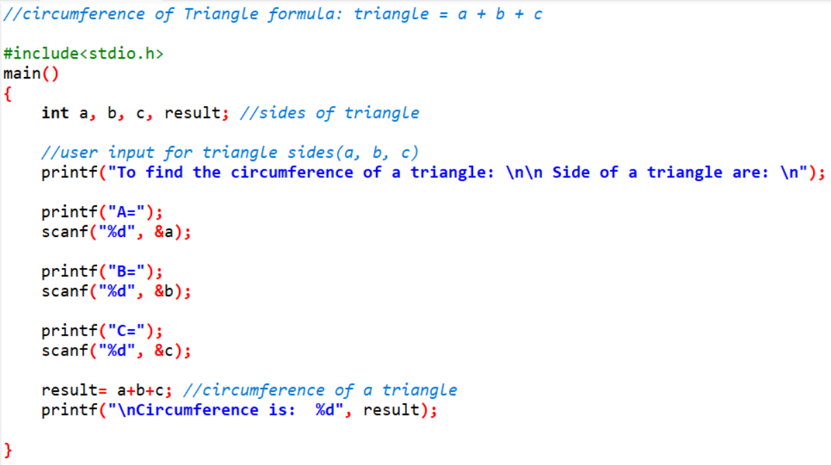 **9. Find circumference of Triangle formula: triangle = a + b + c.**

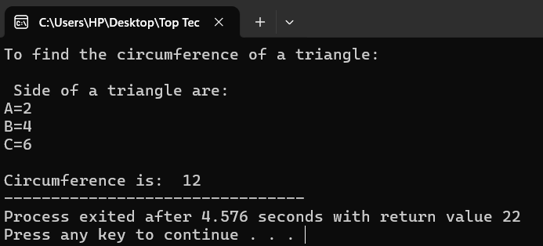**Output:**

**10. find the area of a rectangular prism formula: A=2(wl+hl+hw).**

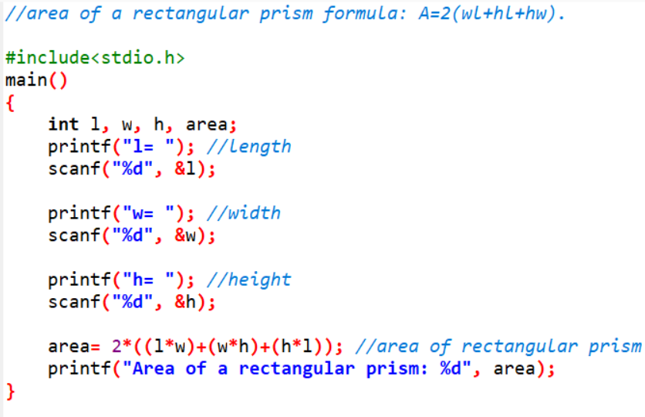

**Output:**

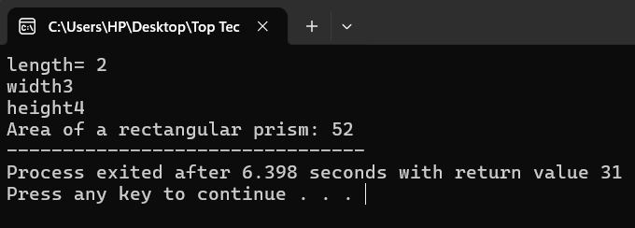

**11. Find circumference of square formula: C = 4 * a.**

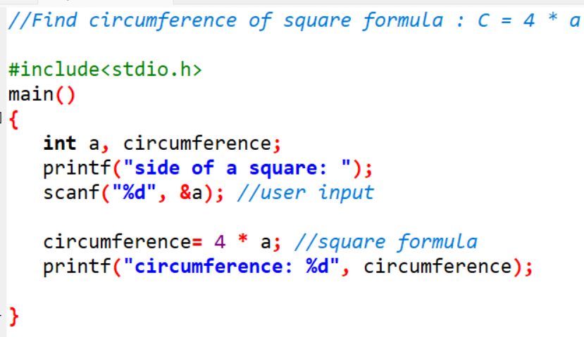

**Output:**

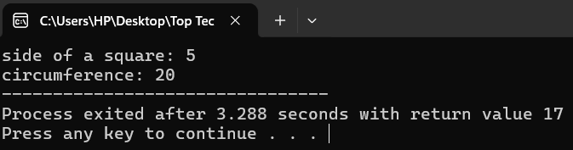

**12. Accept number of students from user. I need to give 5 apples to each student. How many apples are required?**

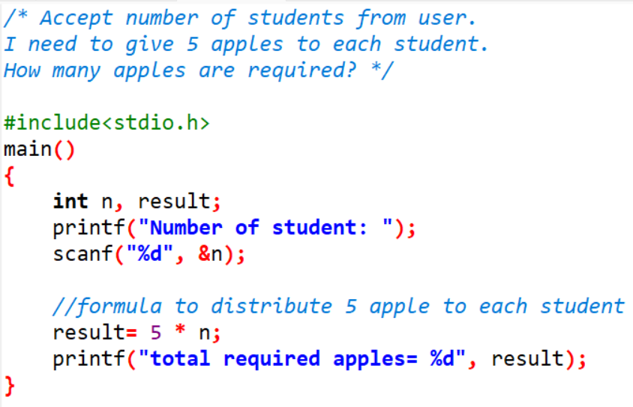

**Output:**

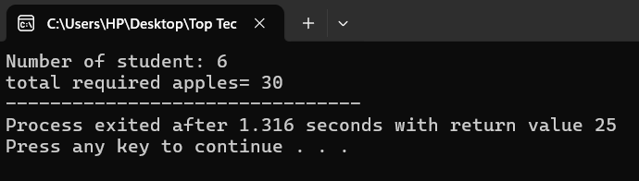

**13. Find character value from ascii.**

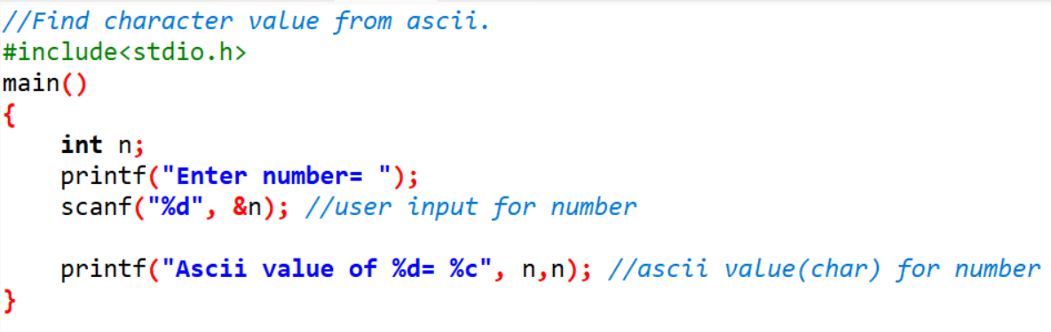

**Output:**

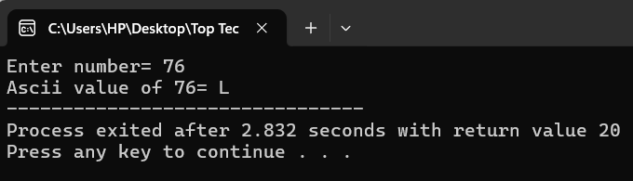

**14. Find ascii value of given number.**

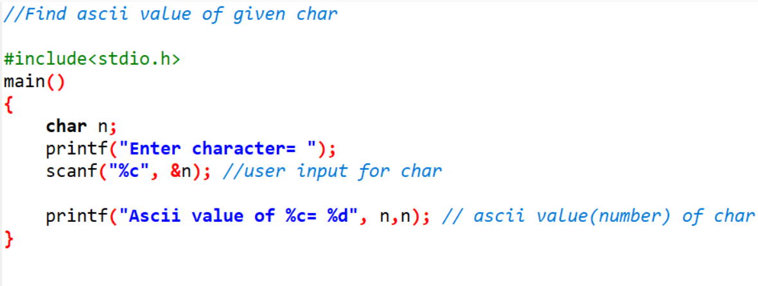

**Output:**

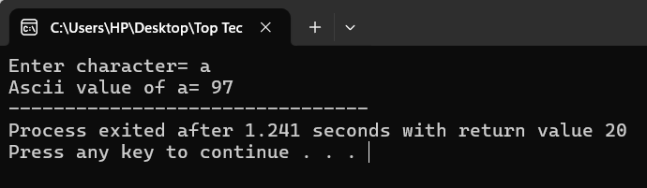

**15. Convert school’s name in abbreviated form Topics Covered Control Statements Conditional Statements.**

**16. Convert country’s name in abbreviate form**

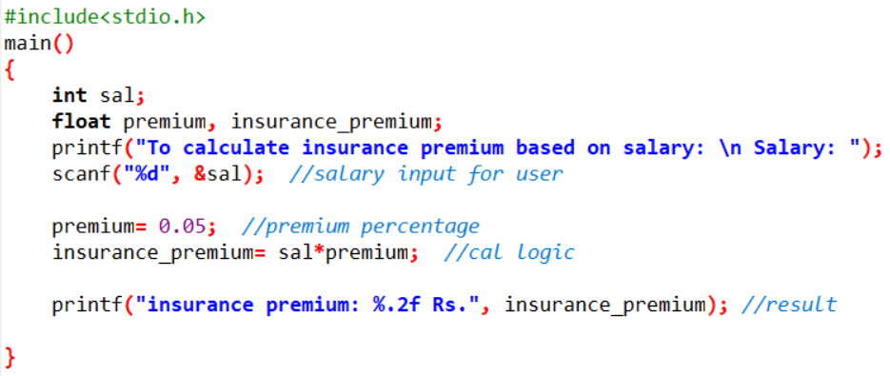**17. Calculate person’s insurance premium based on salary.**

**Output:**

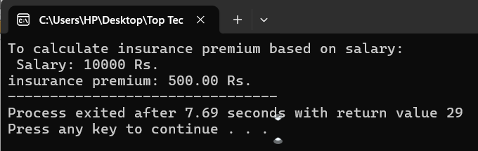

**18. Calculate person’s Annual salary.**

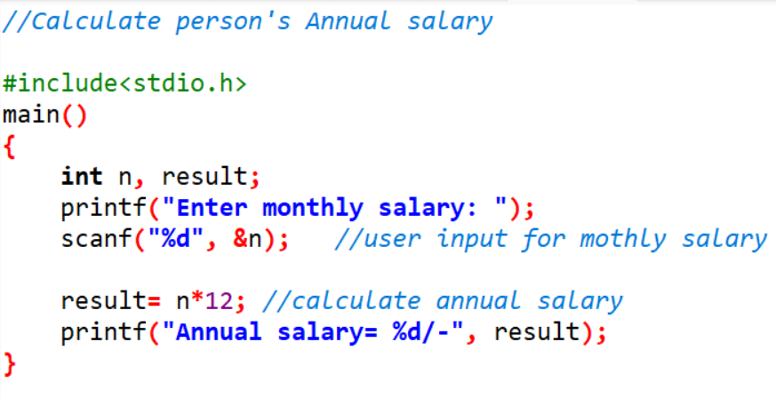

**Output:**

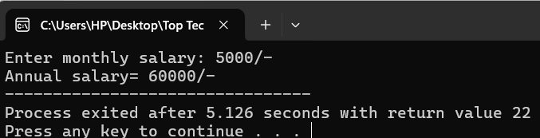

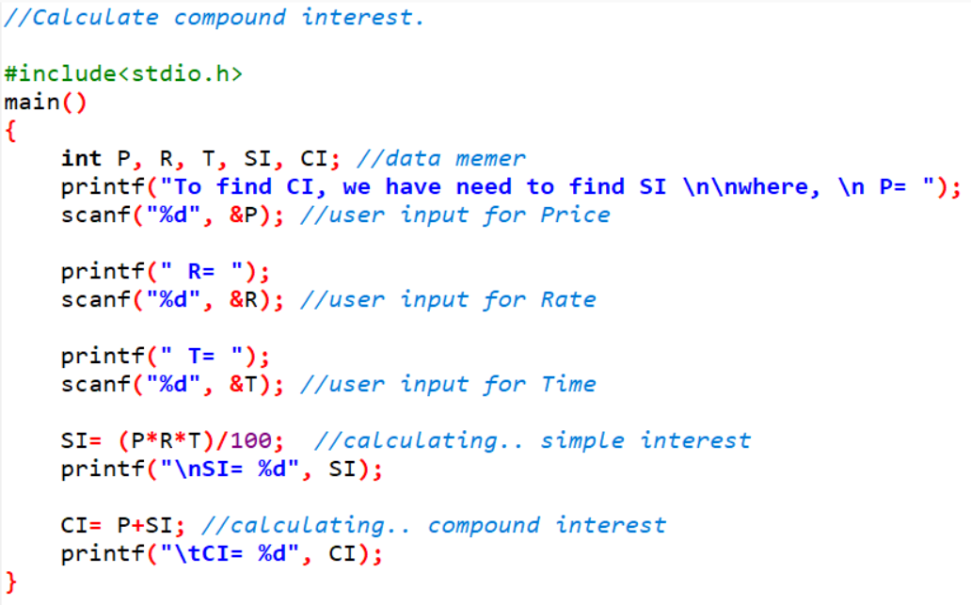**19.Calculate compound interest.**

**Output:**

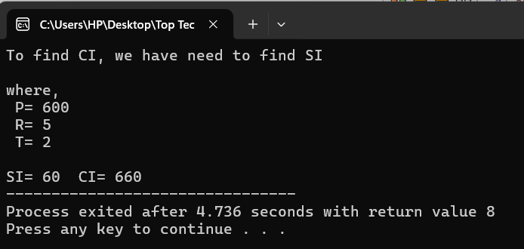

**20. Accept monthly salary from the user and deduct 10% insurance premium, 10% loan installment find out of remaining salary.**

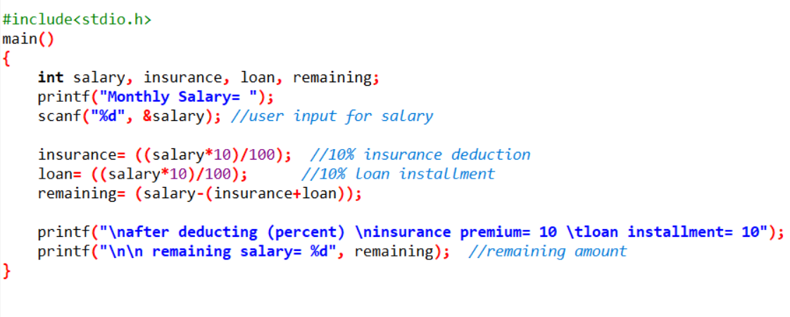

**Output:**

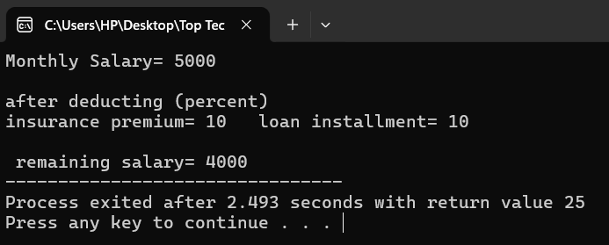

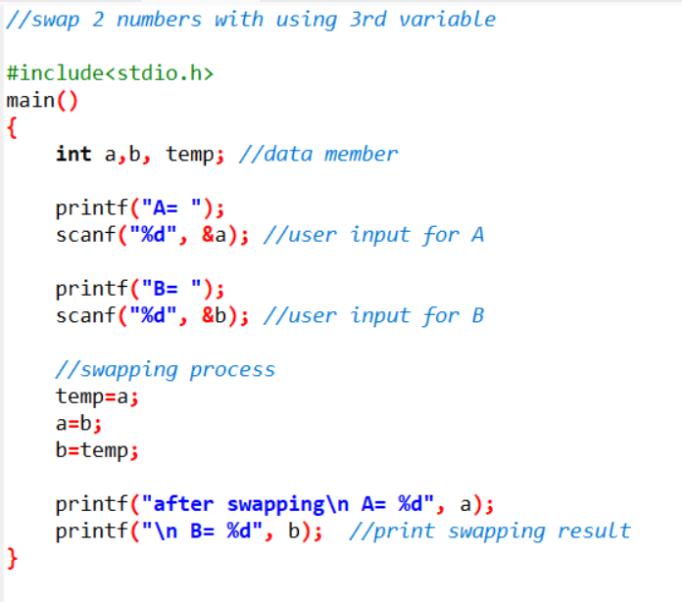**21. Accept 2 numbers from user and swap 2 numbers with using 3rd variable and without using 3rd variable.**

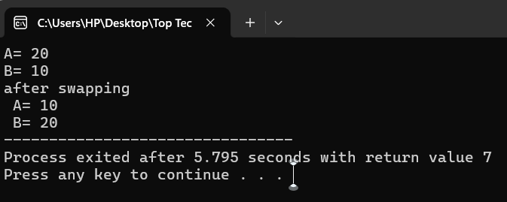 **Output:**

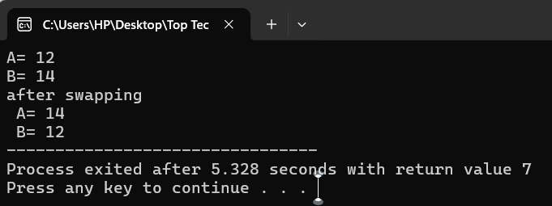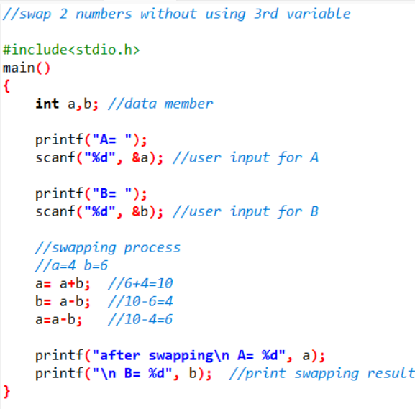 **Output:**

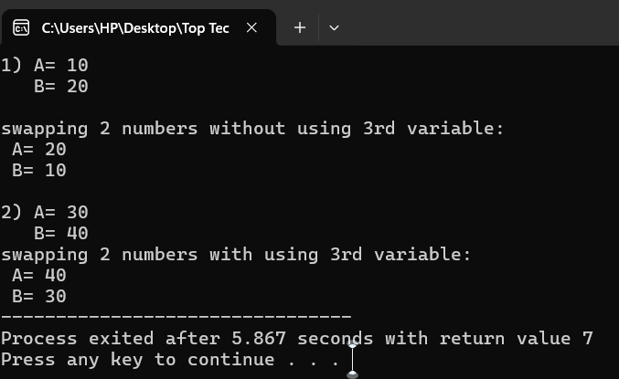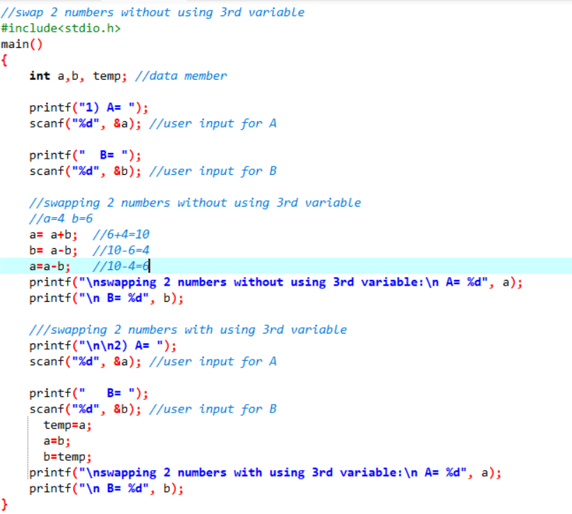**Output:**

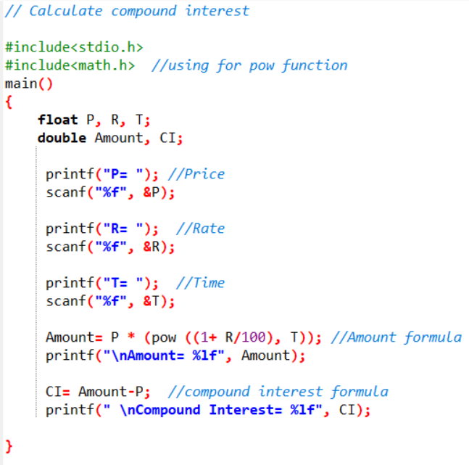**22. Calculate compound interest (Compound Interest formula: a. Formula to calculate compound interest annually is given by: Amount= P (1 + R/100)t b.**

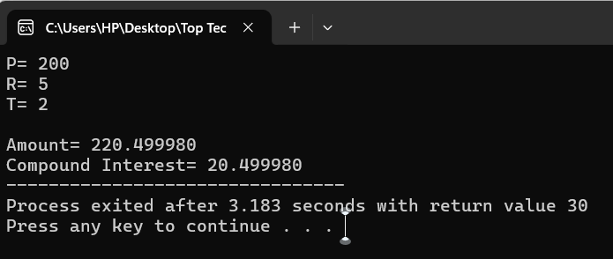**Output:**

**23. WAP to calculate swap 2 numbers with using of multiplication and division.**

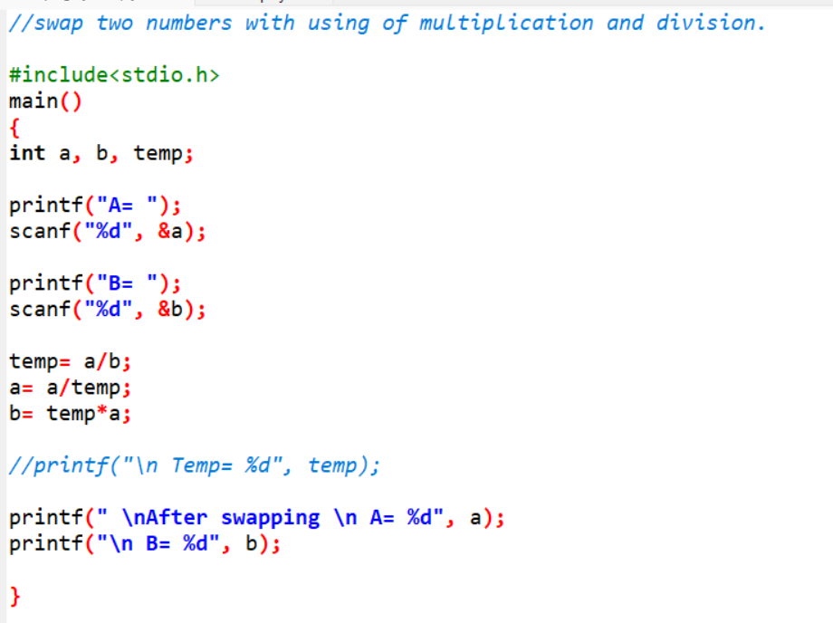

**Output:**

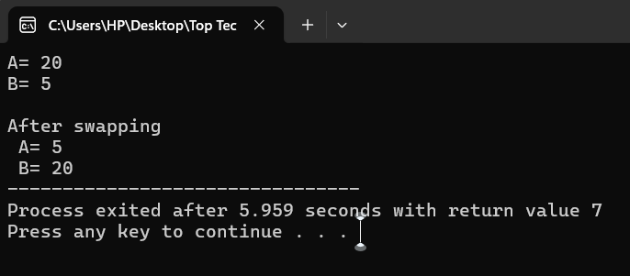

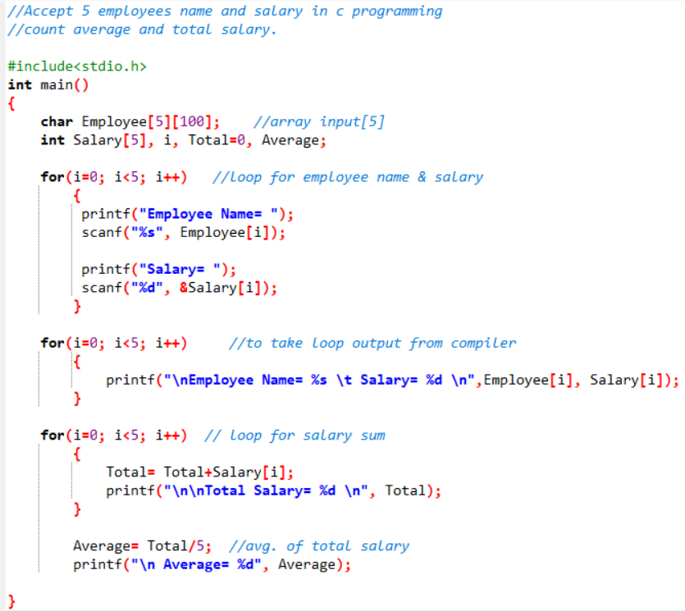**24. Accept 5 employees name and salary and count average and total salary.**

**Output:**

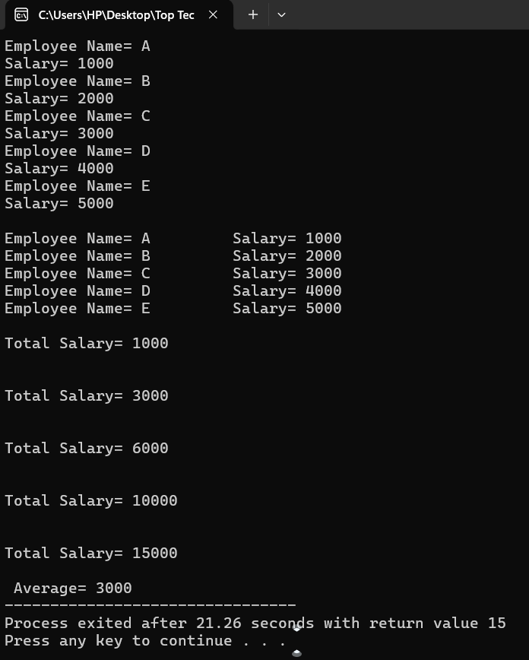

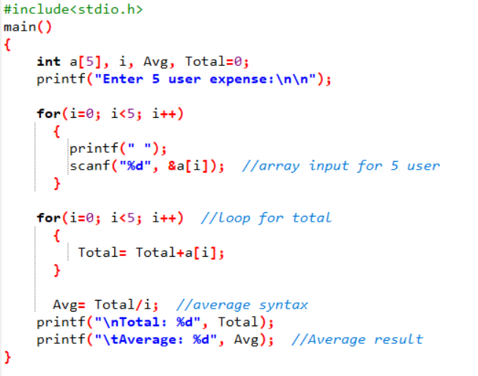**25. Accept 5 expense from user and find average of expense.**

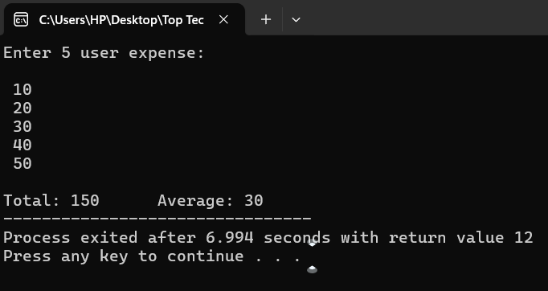**Output:**

**26. Convert temperature Fahrenheit to Celsius.**

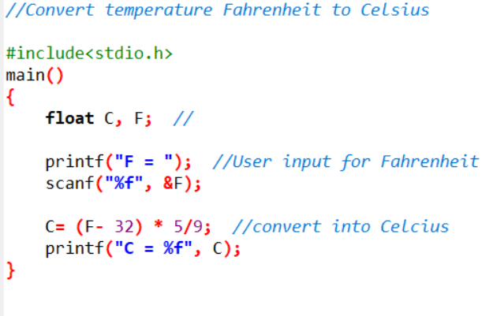

**Output:**

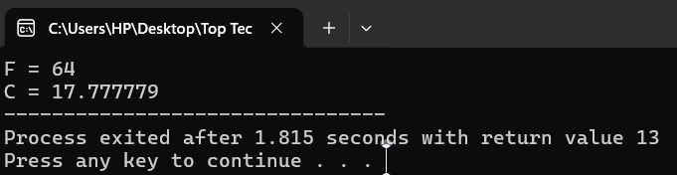

**27. Convert days into months.**

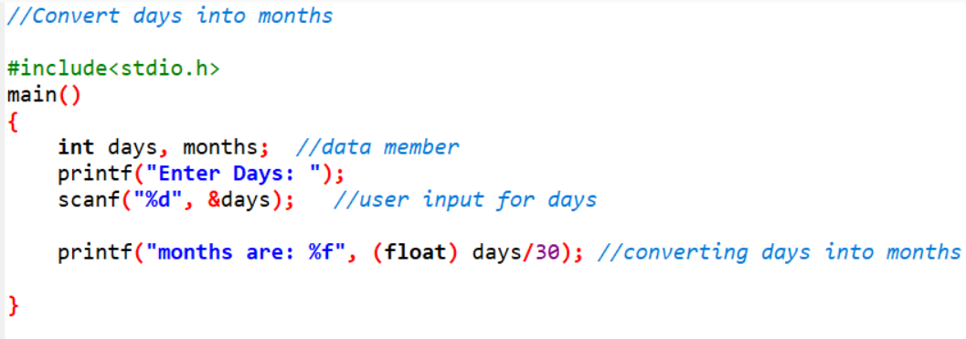

**Output:**

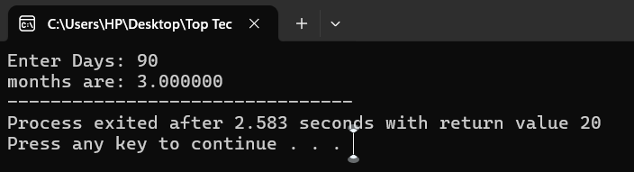

**28. Convert years into days and months.**

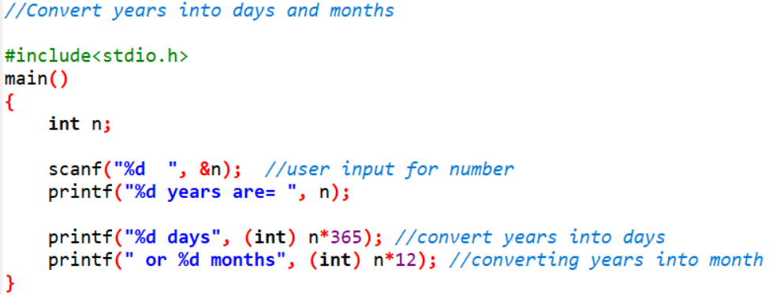

**Output:**

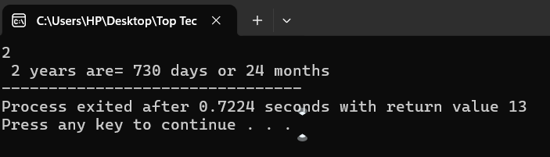

**29. Convert minutes into seconds and hours.**

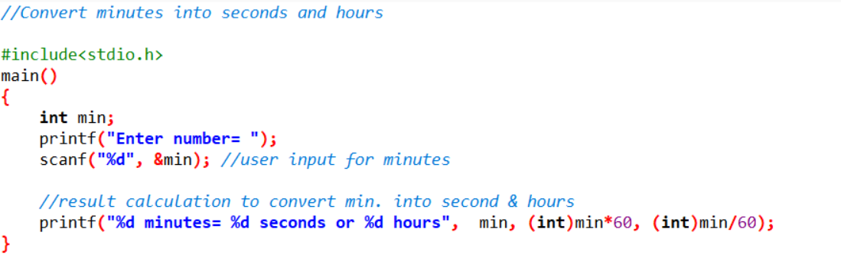

**Output:**

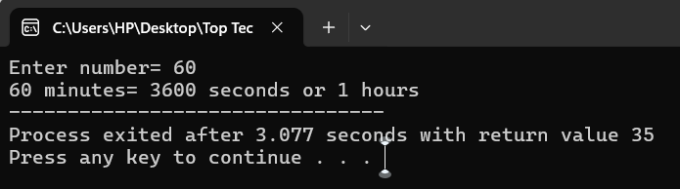

**30. WAP to convert years into days and days into years.**

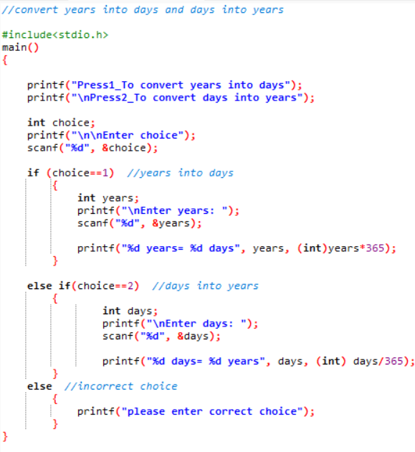

**Output:**

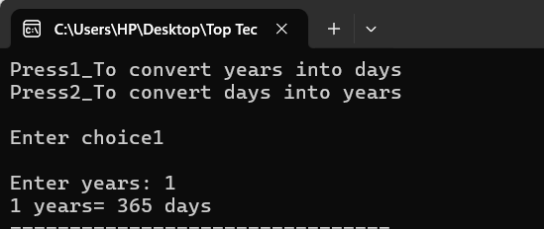

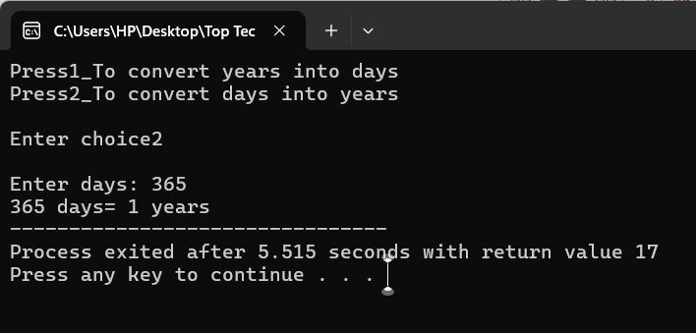

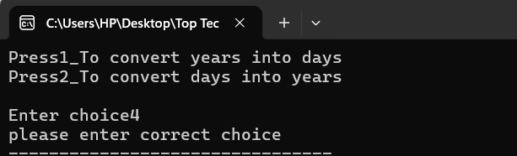

**31. Convert kilometers into meters.**

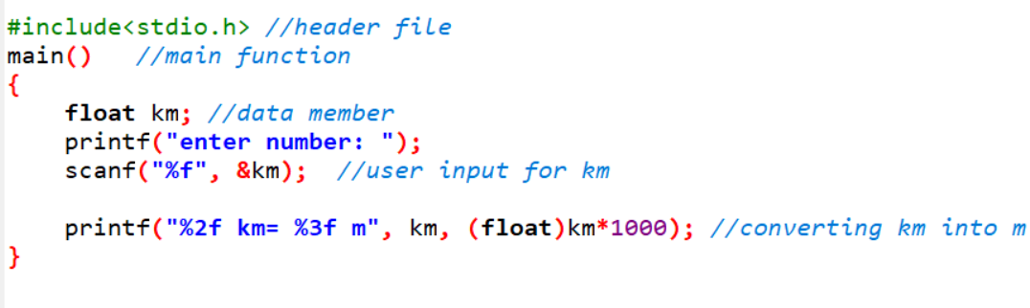

**Output:**

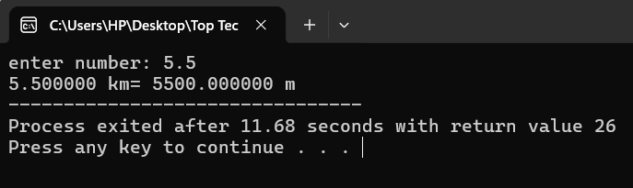

**32. Accept 2 numbers and find out its sum check it size.**

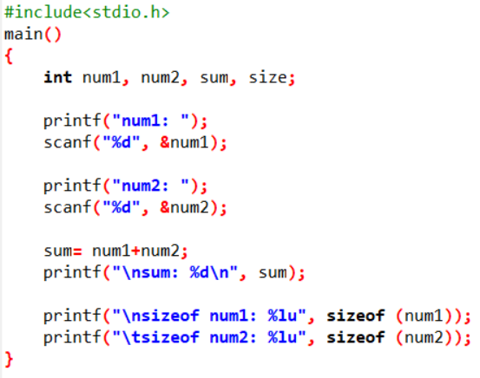

**Output:**

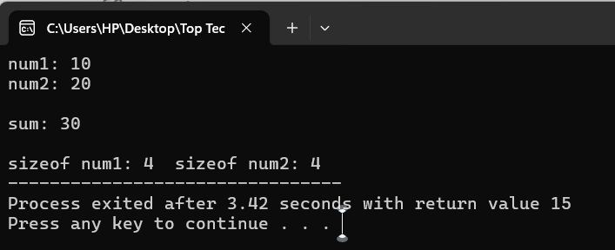

**33. C Program to Read Integer and Print First Three Powers (N^1, N^2, N^3)**

* **15. Convert school’s name in abbreviated form.**
* **16. Convert country’s name in abbreviate form.**
* **33. C Program to Read Integer and Print First Three Powers (N^1, N^2, N^3).**